2011 can be directly downloaded, seems like the most straightforward of the options:
https://drive.google.com/file/d/0B5g07T_gRDg9Z0lsSTEtTWtpOW8/view?resourcekey=0-cozD56gA4fUDdrkHnLJSrQ
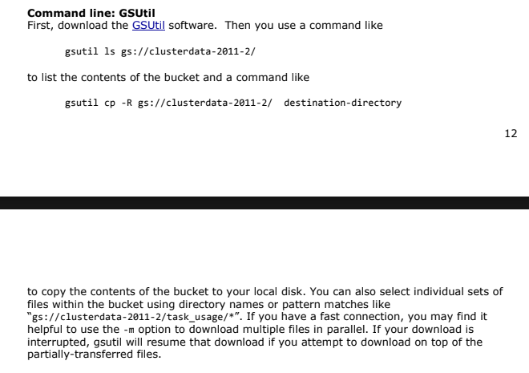
This is a much smaller dataset at ~50GB. The other is 2TB+
Found this script that should download everything: https://github.com/cloudsimplus/cloudsimplus/blob/master/script/download-google-cluster-data.sh
2019 requires you to use Google’s “BigQuery” – they give you $300 in credits, and the documentation for the dataset says that although the data is free, using BigQuery will consume project resources.
https://drive.google.com/file/d/10r6cnJ5cJ89fPWCgj7j4LtLBqYN9RiI9/view
I did find a sample though: https://www.kaggle.com/datasets/derrickmwiti/google-2019-cluster-sample?resource=download
Downloaded it and its got ~400k traces. In the grand scheme of things, don’t think that’s enough though.

Found a google forum where they provided a script to download the data outside of big query
https://groups.google.com/g/googleclusterdata-discuss/c/l1MOcbaeUEg?pli=1

Decided to go 2019
#!/usr/bin/env bash

CELL="a"
TABLE="instance _events"

trace_file_url() {
local cell=$1
local table=$2
local index=$3
# Note that the index in the URL is always a 12-digit number with left-pad zeros
printf "https://storage.googleapis.com/clusterdata_2019_%s/%s-%012d.json.gz" $cell $table $index
}

idx=0
while true; do
if ! wget $(trace_file_url $CELL $TABLE $idx); then
# When reaches to a non-exist file which fails wget, stop the script
# Ideally, it should check if the error is NOT FOUND, rather than some network issue, or whatnot
exit 0
fi
idx=$((idx + 1))
done

That being said, the author also hihghlighted: We found BigQuery is extremely useful for us to analyze a dataset of this size. We can run pretty complicated analysis using a SQL query within seconds or minutes against several TiB of data using BigQuery. Almost all analysis we've done for the Eurosys 2020 paper, Borg: The Next Generation, has done using BigQuery. That said, you are free to use whatever tool you want to analyze the data. We just feel BigQuery is sufficient for most of the analysis work we need to do.

Downloading (edited the above to have a max number of installs):
#!/usr/bin/env bash

CELL="a"
TABLE="machine_events"

# Stop at numeric index 100
MAX_IDX=10

# Manually specify starting index
START_IDX=0

trace_file_url() {
local cell=$1
local table=$2
local index=$3
printf "https://storage.googleapis.com/clusterdata_2019_%s/%s-%012d.json.gz" \
"$cell" "$table" "$index"
}

idx=$START_IDX

while [ "$idx" -le "$MAX_IDX" ]; do
url=$(trace_file_url "$CELL" "$TABLE" "$idx")
echo "Downloading index $idx: $url"

# Capture stdout/stderr
output=$(wget "$url" 2>&1)
status=$?

if [ $status -ne 0 ]; then
echo "Download failed for index $idx:"
echo "$output"
echo "Continuing..."
# Remove partial file if wget created one
rm -f "$(printf "%s-%012d.json.gz" "$TABLE" "$idx")"
fi

idx=$((idx + 1))
done

Trying to parse into csv files:
#!/usr/bin/env bash

# Usage:
# ./instance_events_to_csv.sh instanc_events-000000000000.json.gz 1000
#
# Reads N lines from a gzipped instance_events JSONL file
# and writes ALL fields from the schema into a CSV file.
#
# Requires: jq, zcat (gzip)

INPUT_GZ="$1 "
NUM_LINES="$2"

if [[ -z "$INPUT_GZ" || -z "$NUM_LINES" ]]; then
echo "Usage: $0 <file.json.gz> <number-of-lines>"
exit 1
fi

if [[ ! -f "$INPUT_GZ" ]]; then
echo "Error: file '$INPUT_GZ' not found."
exit 1
fi

OUTPUT_CSV="${INPUT_GZ%.json.gz}.csv"

echo "Reading $NUM_LINES lines from $INPUT_GZ"
echo "Writing CSV to $OUTPUT_CSV"

# ---- CSV HEADER: every field from instance_events schema ----
echo "time,type,collection_id,scheduling_class,missing_type,collection_type,priority,alloc_collection_id,instance_index,machine_id,alloc_instance_index,resource_request_cpus,resource_request_memory,constraint_names,constraint_values,constraint_relations" > "$OUTPUT_CSV"

# ---- PROCESS: read N lines, flatten JSON, append as CSV ----
zcat "$INPUT_GZ" \
| head -n "$NUM_LINES" \
| jq -r '
[
.time,
.type,
.collection_id,
.scheduling_class,
.missing_type,
.collection_type,
.priority,
.alloc_collection_id,
.instance_index,
.machine_id,
.alloc_instance_index,
.resource_request.cpus,
.resource_request.memory,

# constraint is REPEATED RECORD → flatten each subfield with "|"
((.constraint // []) | map(.name) | join("|")),
((.constraint // []) | map(.value) | join("|")),
((.constraint // []) | map(.relation | tostring) | join("|"))
] | @csv
' >> "$OUTPUT_CSV"

echo "Done: $OUTPUT_CSV"

